Access windows remotely using rdp running on the virtual box.

Steps:

To add the port forwarding for the windows.

Enabled RDP

Disable firewall for RDP

Step1:

To add the port forwarding for the windows.

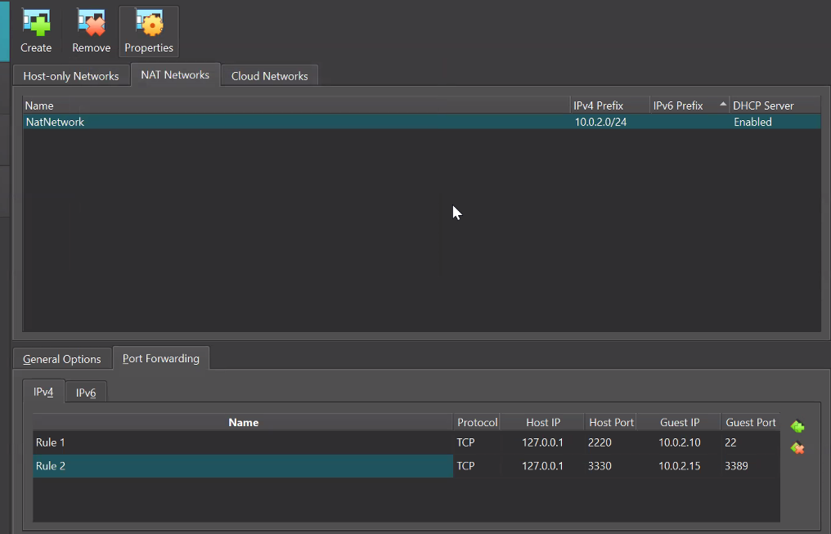

Here the assumption is windows Ip is “10.0.2.15” that is set in the Rule2.

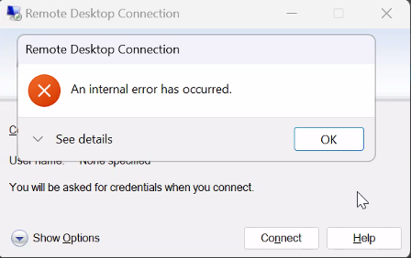

Step2:

Enabled Remote Desktop on the server .

By default the remote desktop is disabled on the servers.

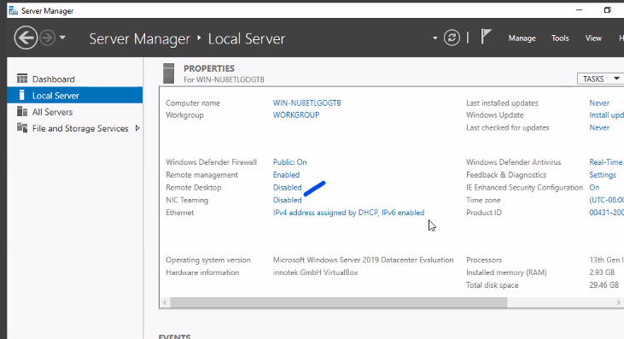

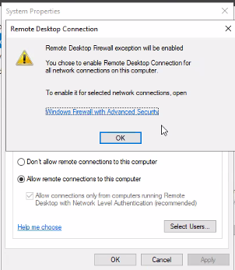

Once you click “OK”, untick the last option

It would be enabled.

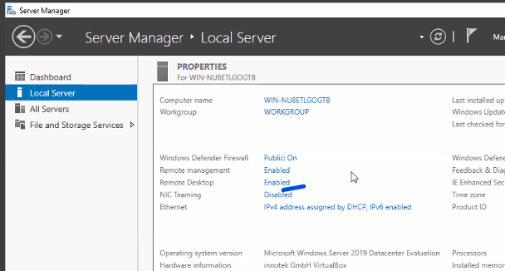

Step3:

Disable firewall for RDP